**A.** Classic voltage regulators use NPN BJTs / N-ch MOSFETs in emitter / source follower configuration.

**1.** For NPN-type voltage regulators VIN - VOUT > RIN x IIN + 2 × VBE.

Example: RIN = 1 kΩ, IIN = 1 mA, VBE = 0.7 V the minimum input voltage required to generate a 5 V output is calculated to be 7.4 V.

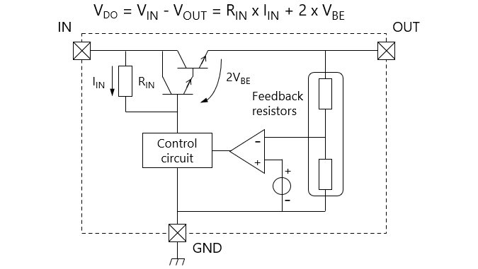

**2.** For MOSFET-based voltage regulators VIN - VOUT > RIN × IIN + VGS.

Example: RIN = 1 kΩ, IIN = 1 mA, VGS = 1 V the minimum input voltage required to generate a 5 V output is calculated to be 7 V.

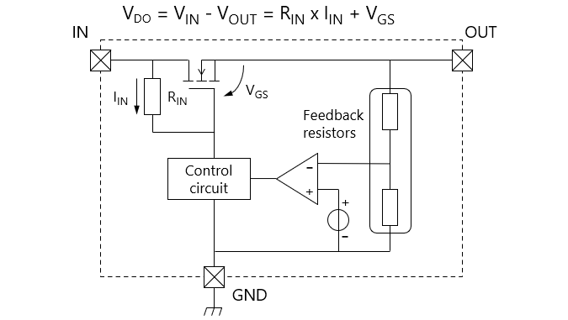

**B.** LDO regulators use PNP BJTs / P-ch MOSFETs (pass transistors) in common emitter / source configuration.

The minimum dropout voltage of such LDO regulators is determined by the collector-emitter voltage (VCE(sat)) and the drain-source voltage (VDS = RDS(ON) × ID). Therefore, LDO regulators can operate with a smaller dropout voltage than classic voltage regulators.

